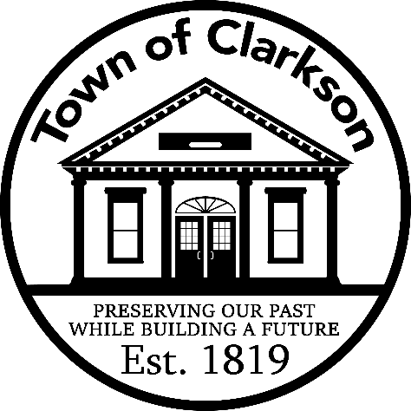

BUSINESS ADVERTISING APPLICATION
For logo added to “Welcome to Clarkson” sign

If you would like your business logo advertised on a panel under one or more “Welcome” signs in town, please complete this application, and email your logo to townclerk@townofclarksonny.gov. We will take it from there! Your logo will be sent to our sign company and once a firm quote is received, we will provide it to you. The amount must be prepaid to the “Town of Clarkson” before we can place the sign order.

Company Name: ________________________________________________
Contact Person: ____________________________________________
Phone: ____________________________________________
Email: ____________________________________________
Address: ____________________________________________
____________________________________________
Estimate of Sign: Approximately $950 (includes hardware and hanging)
Annual Fee: One sign: $300
Two or more signs: +$150 each (i.e. 2 signs = $450)
Billed the first January AFTER your sign is in place

Welcome Sign Locations (please check off desired location):

____ West end of Ridge Road/Route 104 ____ South end of Lake Road/Route 19
____ East end of Ridge Road/Route 104 ____ North end of Lake Road/Route 19

_________________________________ __________________
Signature of Contact Person Date

