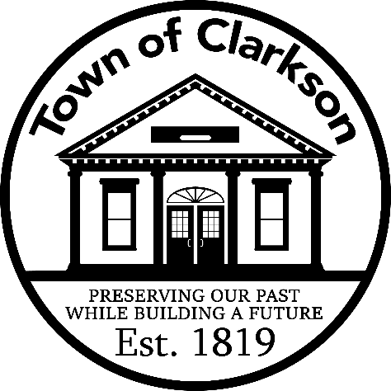
NOTICE TO RESIDENTS
October 28, 2025

SPECIAL DISTRICTS:
As you know, the town includes several Special Districts – water, sewer, lighting, and sidewalk. Each Special District is made up of several roads and subdivision streets. When these districts were created, a tax was applied to each parcel to pay for the expense of the benefit received. This is not an expense that is shared townwide because the benefit is specific to the district and is added as a separate line item on the annual town and county tax bill. As parcels are added to a district, i.e., new homes are built, the proportionate amount per parcel is adjusted.
In theory, the amount that the town collects from each tax payment should cover the expense of each Special District. However, the cost to the town has increased over the years but it has not been passed on to the taxpayers causing the town to be in a deficit in certain districts. We are in the process of remedying this going forward, and certain districts may see an increase in their tax bills in 2026.
TAX LEVY and TAX CAP:
Each year, the NYS Office of State Comptroller (OSC) requires that a form be prepared to calculate the maximum tax levy, i.e., the total amount of money that the town can collect through property taxes. The OSC form is prepared by the town’s accountant.

For 2026, the maximum tax levy calculated on the OSC form = $1,636,673.00. This is the highest amount the town can levy against residents through property taxes without exceeding the 2% tax cap set by NYS. This amount includes the expenses to run the town, plus all Special Districts as required by NYS.

After budget preparation, the amount of the 2026 tax levy per the tentative budget, including the Special Districts equals: $1,832,393.52
Minus the maximum levy per the OSC calculation: - 1,636,673.00
Equals the tax cap overage: $ 195,720.52

EXPLANATION:
Although we have exceeded the tax cap for 2026, the overage is due to the Special Districts as noted below and is applicable ONLY to the residents who receive the benefits; it is not townwide.

- WIBA No. 1 Water District. This project brings MCWA water service to all town roads and residents who previously had private wells for water. This included five main roads in town, Sweden Walker Road, County Line Road, Lawton Road, West Avenue and Ireland. This water project was approved by residents in 2023 through a vote, and construction started in late 2024. Residents were not obliged to tap into the service, but it has now been made available to them. At present, the project is very close to completion.

In order to finance the construction, the town received a one-year note of $4.7M in November 2024, and it was paid off with interest in October 2025 by a bond (loan) received from USDA Rural Development at 1.5% interest for 38 years. The bond payments of $160,250.00 (principal & interest on the bond) will begin in 2026 and continue through 2063. This created an increase in the property tax levy of $160,250.00 for 2026 and only affects residents in the WIBA No. 1 Water District.

- Sewer District 2 – Greenfield Manor. This neighborhood required a significant sewer repair project earlier this year, and the cost to the town needs to be recovered. The recovery process was approved by the Town Board and was outlined in a letter to the residents in that district, over a two-year period beginning in 2026. This created an increase in the property tax levy of $48,059.00.

Since we have exceeded the tax cap for 2026, a local law must be passed to allow for this ahead of accepting the budget. A public hearing is set for November 11, 2025, as part of the regularly scheduled Town Board meeting to accept the preliminary and/or final budget.

Please note that exceeding the tax cap is a different issue from being over budget. This occurs if an appropriation or expense line within the adopted budget exceeds the amount budgeted. We are not over budget for 2026.

Also, although we exceeded the tax cap for 2026, it does not automatically mean the town will exceed it again in 2027, unless new debt is incurred for a Special District, like what happened this year. The tax cap calculation on the OSC form for 2027 will be based on the higher 2026 levy of $1,832,393.52.

We hope this information helps to explain the status of our budget for 2026 and the expected increases in the upcoming town and county tax bills.

Clarkson Town Board

