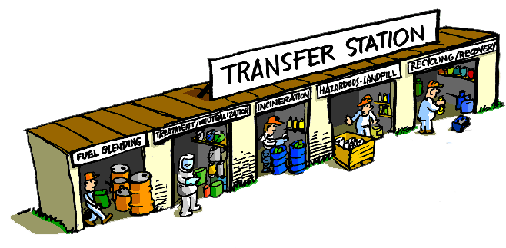
2026
TRANSFER STATION PERMITS
ON SALE starting MONDAY 12/1- at the Town Hall
(for Clarkson residents only)
** $275 **
PLEASE BRING IN YOUR VEHICLE REGISTRATION

